* **Lab Task 1**

Increase the commission percentage for every employee in department 80 by 5%

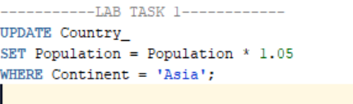

OUTPUT: